Software Requirements
Specification

A Mobile Application for Facility Management

Team
[Bug Off]

Members
[Morin Refaat] | [13001321] (TeamLead)
[Lina Khaled] | [13001326]
[Andrew George] | [13006966]
[Zeina Ghalab] | [13001300]
[Leila Ashraf] | [13004147]
[Hannah Nagy | [13007141]
[jomana walid] [13002562]
[mohamed waleed] [13007046]

Tutorial Details
[T6] | [Hassan Usama]

Introduction

This document presents the Software Requirements Specification (SRS) for CampusCare, a mobile-based Facility Management System designed for the German International University (GIU). The system aims to provide a structured, efficient, and transparent platform that enables university community members to report facility-related issues and allows the Facility Management team to manage, track, and resolve these issues effectively.
Purpose of the Software
The purpose of CampusCare is to digitalize and streamline the process of reporting, managing, and resolving infrastructure, maintenance, cleanliness, and sustainability issues across the university campus. The system addresses existing challenges such as unreported issues, delayed maintenance responses, and inefficient communication between community members and the Facility Management team. By providing a centralized reporting and tracking platform, the software aims to improve response times, enhance campus safety, and maintain the university’s facilities as valuable institutional assets.
Intended Audience
The intended audience of this document and the CampusCare system includes:
- GIU community members (students, academic staff, and administrative staff) who report issues through the mobile application.
- Facility Management team members responsible for reviewing, assigning, tracking, and resolving reported issues.
- Assigned workers/technicians who receive tasks and update their progress.
- System administrators who manage user roles and system configurations.
- Project stakeholders, including instructors, teaching assistants, and developers involved in the design, development, testing, and evaluation of the system.
Scope of the Software
CampusCare is a mobile application supported by a backend system that facilitates end-to-end facility issue management. The scope of the system includes:
- Allowing users to submit issues by uploading photos, adding descriptions, and specifying locations.
- Enabling the Facility Management team to view all reported issues, assign personnel, update issue statuses, and monitor progress.
- Notifying relevant users when issues are submitted, assigned, or resolved.
- Supporting multiple user roles with role-based access control to ensure a clear and structured workflow.
The system focuses on campus facility management and does not cover external maintenance services, financial processing, or third-party contractor management.
Overview of the Software
CampusCare is developed as a mobile application using React Native (Expo) with a Node.js backend and RESTful APIs, supported by a relational database and cloud-based image storage. The application serves as a closed-loop communication system between campus users and the Facility Management team. By improving visibility, accountability, and efficiency in handling maintenance issues, CampusCare contributes to a cleaner, safer, and more comfortable campus environment while fostering a sense of shared responsibility among community members.

Campuses are university assets that play a vital role in boosting members’ morale and productivity. They also reflect a positive image of the university — they are, after-all, where newcomers will form their first impressions of the university. Their protection and maintenance is therefore an integral goal of any institution (educational or otherwise). No matter how efficient routine maintenance and cleaning are, it is the case that community members will encounter issues that need addressing. By providing them with an easy, efficient and formal way to communicate these to the Facility Management team, any problems can be quickly and efficiently addressed. Moreover, through the inclusion and empowerment of community members in the maintenance of their shared spaces, their own sense of ownership is boosted. Moreover, the Facility Management team is able, through the application, to assign, track and update the status of the various issues. This closed-loop system serves as a holistic solution that facilitates the university’s comprehensive approach to maintaining hygiene, as well as providing a safe and comfortable experience for community members.

Provides the purpose, intended audience, scope, and overview of the software. You may re-use the problem statement for this part of the introduction (before Section 1.1).

Product Vision & Scope
A mobile application is to be designed and developed to enable members of the GIU community to submit infrastructure, maintenance, sustainability and cleanliness issues that require the attention of the Facility Management team (e.g. broken doors, flickering lights, open windows while the AC is on, and overflowing trash cans). In addition, the system will provide the Facility-Management team with the ability to receive the issues, assign personnel to them, as well as to track and update their status (which in turn is visible to all members). The application contributes to the efficient maintenance of the campus and its protection as an asset. It is expected to lead to faster response times to pending issues and thus to a clean, comfortable and safe environment for community members. The solution will be developed as a mobile application using React Native (Expo) and a backend system using Node.js and RESTful APIs.

Defines the overall goals of the system (You may re-use the overview section of the project description for this part).

1.2 Definitions and Acronyms

SRS: Software Requirements Specification
Ticket: A digital record representing a maintenance issue
RBAC: Role-Based Access Control
FM (Facility Management):
The department responsible for reviewing, assigning, and verifying maintenance issues reported in the system.
Worker:
A technician or maintenance staff member assigned to resolve facility issues.
CampusCare:
The mobile application developed to manage and track campus facility issues.
Ticket Status:
The current stage of a maintenance issue in the workflow (e.g., Submitted, Assigned, In Progress, Under Review, Resolved).
Note: The system uses extended statuses.
“Submitted” is equivalent to “Pending” as defined in the base requirements.

Functional Requirements

Describes what the system should do, first in the form of user stories then as a list of functional requirements for each user/role. A UML use-case diagrams should then be included to link specific features and requirements.

2.1 User stories:
A. Community Member
US-U-01: User Registration
As a community member, I want to sign up using my university email address, so that I can create a personal account and access the system.
US-U-02: User Authentication
As a community member, I want to log in using my email credentials, so that I can securely access my account.
US-U-03: Create Maintenance Ticket
As a community member, I want to report a facility issue by uploading a photo,
selecting the building, floor, room number, and selecting a category,
and entering a description, so that the Facility Manager can understand the issue clearly.
US-U-04: Media Restriction
As a community member, I want the system to allow only image uploads and reject video files, so that system storage limitations are respected.
US-U-05: Mandatory Field Validation
As a community member, I want the system to prevent ticket submission if required fields (photo, location, description, category) are missing, so that incomplete reports are not sent.
US-U-06: View Own Tickets
As a community member, I want to view only the tickets that I have submitted, so that my data remains private and secure.
US-U-07: Track Ticket Status
As a community member, I want to view the current status of my ticket (Submitted, Assigned, In Progress, Resolved, Rejected), so that I can track the progress of my issue.
US-U-08: Receive Status Notifications
As a community member, I want to receive notifications whenever the ticket status changes, so that I stay informed without repeatedly checking the application.
US-U-09:
As a community member, I should be able to submit a forgot my password request.
US-U-10: (Gamification)
As a community member, I want to earn "Acts of Service" points for every valid issue I report, so that I can be rewarded with a bonus grade at the end of the semester.
US-U-11: Logout
As a community member, I want to log out so that my data remains secure.
B. Facility Management
US-FM-00: Account Creation
As a facility manager, I want to create an account so that I can access the system.
US-FM-01: Facility Management Authentication
As a facility management member, I want to log in using credentials created by the Admin, so that only authorized staff can access facility operations.
US-FM-02: View Incoming Tickets
As a facility management member, I want to view all submitted tickets with their photos, descriptions, and locations, so that I can assess reported issues.
US-FM-03: Review Ticket Details
As a facility management member, I want to inspect ticket images and descriptions in detail, so that I can decide the appropriate action.
US-FM-04: Automatic Priority Detection
As a facility management user, I want the system to automatically increase the priority of an issue when multiple users report the same location, so that critical problems are handled first.
Example:
If 3 or more tickets are submitted for Building A – Floor 2 – Room 205, the system marks the issue as High Priority.

US-FM-04: Assign Ticket to Worker
As a facility management member, I want to assign a ticket to a specific worker, so that responsibility for resolving the issue is clearly defined.
US-FM-05: Update Ticket Status to Assigned
As a facility management member, I want to update the ticket status to “Assigned” after assigning a worker, so that the workflow state is accurate.

US-FM-06: Receive Worker Updates
As a facility management member, I want to receive status updates from the worker after work is performed, so that I can verify resolution.
US-FM-07: Verify Issue Resolution
As a facility management member, I want to review the worker’s update and confirm whether the issue has been resolved, so that incorrect closures are avoided.
US-FM-08: Request Rework
As a facility management member, I want to send the ticket back to the worker if the issue is not fully resolved with a description of reason, so that the problem is handled correctly.
US-FM-09: Close Ticket
As a facility management member, I want to mark the ticket as “Resolved” after verification, so that the issue lifecycle is completed.
US-FM-10: Notify User of Resolution
As a facility management member, I want the system to notify the user once the ticket is confirmed as resolved, so that the user is informed of the outcome.
US-FM-11:
As a facility management member, I should be able to view the profile for each worker to ensure smooth communication and to prevent wrong assignments
US-FM-12:
As a facility management member, I should be able to filter all the tickets based on their status to make it easier to search for tasks.
US-FM-13:
As a facility Management member, I should be able to add priority on the tasks to make sure the tasks with higher priorities gets assigned first.
US-FM-14: Logout
As a facility manager, I want to log out so that my data remains secure.

C. Worker
US-W-00: Account Creation
As a worker, I want to create an account so that I can log in.
US-W-01: Worker Authentication
As a worker, I want to log in using credentials created by the Admin, so that I can securely access assigned tasks.
US-W-02: View Assigned Tickets
As a worker, I want to view only the tickets assigned to me, so that I can focus on my responsibilities.
US-W-03: View Ticket Details
As a worker, I want to view the ticket photo, description, and location, so that I can understand the issue before starting work.

US-W-04: Update Work Status
As a worker, I want to update the ticket status to “In Progress” while working on the issue, so that Facility Management is aware of progress.
US-W-05: Submit Resolution Update
As a worker, I want to submit a status update after completing the task, so that Facility Management can review the work.
US-W-06: Comment on Issue
As a worker, I want to add comments so that I can communicate updates.
US-W-07: Logout
As a worker, I want to log out so that my data remains secure.

D. Admin
US-A-01: Admin Authentication
As an admin, I want to log in with full system privileges, so that I can manage users and system configuration.
US-A-02: Create Facility Management Accounts
As an admin, I want to approve Facility Management accounts after registration, so that only authorized staff can access management features.
US-A-03: Create Worker Accounts
As an admin, I want to approve Worker accounts after registration, so that only authorized maintenance staff can access assigned tasks.
US-A-04: Assign Roles and Permissions
As an admin, I want to assign roles and permissions using RBAC, so that each user only accesses allowed features.
US-A-05: Full System Visibility
As an admin, I want to view all tickets, users, and activities, so that I have complete oversight of the system.
US-A-P-06: Assign Roles
As an admin, I want to assign a specific role (User, Worker, Facility Management, Admin) to each account, so that permissions are applied correctly.
US-A-P-08: Full System Access
As an admin, I want to view all tickets, users, statuses, and actions, so that I have full oversight of the system.

US-A-11: Activate/Deactivate Accounts
As an admin, I want to activate or deactivate user accounts,
so that I can ensure only valid users can access the system.

US-A-12: View All Users
As an admin, I want to view all registered users,
so that I can manage and monitor the system users.
US-A-13: Logout
As an admin, I want to log out so that my data remains secure.

FUNCTIONAL REQUIREMENTS SPECIFICATION:

2.1 Authentication & Account Management
FR-01: User Registration
- The system shall allow a community member to register using a valid university email address.
Priority: High
FR-05: Login Authentication
- The system shall authenticate users using email and password credentials before granting access before granting access.
Priority: High
FR-06: Forgot Password
- The system shall allow users to request a password reset via email verification.
Priority: Medium
2.2 Role-Based Access Control (RBAC)
FR-08: Role Assignment
- The system shall assign one of the following roles to each account: Community member, Worker, Facility Management, or Admin.
Priority: High
FR-09: Role-Based Permission Enforcement
- The system shall restrict system functionality based on the assigned role.
Priority: High
FR-10: Community User Restrictions
- The system shall prevent community members from modifying ticket status, assigning tickets, deleting tickets, or viewing other users’ tickets.
Priority: High
FR-11: Worker Restrictions
- The system shall prevent workers from closing tickets as “Resolved” or viewing unassigned tickets.
Priority: High
FR-12: Facility Management Restrictions
- The system shall prevent facility management users from creating or deleting user accounts.
Priority: Medium
FR-13: Admin Privileges
- The system shall grant the Admin full system access and override capabilities.
Priority: High

2.3 Ticket Creation & Validation
FR-14: Ticket Creation
- The system shall allow authenticated community members to create a maintenance ticket.
Priority: High
FR-15: Mandatory Fields
- The system shall require image, building, floor, room, category and description before submission.
Priority: High
FR-16: Media Restriction
- The system shall accept image files only and reject video uploads.
Priority: High
FR-17: Submission Confirmation
- The system shall notify the user upon successful ticket submission.
Priority: Medium
FR-18: Issue Category
The system shall allow users to select a predefined issue category
(e.g., Electrical, Plumbing, Cleanliness, Infrastructure).
Priority:High
FR-19: Account Activation Control
The system shall allow the Admin to activate or deactivate user accounts.
Priority: Medium

FR-20: View Registered Users
The system shall allow the Admin to view all registered users in the system.
Priority: Medium

2.4 Ticket Workflow Management
FR-21: Initial Ticket Status
- The system shall set ticket status to “Submitted” upon creation.
Priority: High
FR-22: View All Tickets
- The system shall allow Facility Management to view all tickets.
Priority: High
FR-23: Ticket Assignment
- The system shall allow Facility Management to assign tickets to workers.
Priority: High
FR-24: Worker View Restriction
- The system shall allow workers to view only assigned tickets.
Priority: High
FR-25: Work Progress Update
- The system shall allow workers to update status to “In Progress.”
Priority: High
FR-26: Completion Submission
- The system shall allow workers to upload a resolution photo and update completion notes.
Priority: High
FR-27: Status Under Review
- The system shall update ticket status to “Under Review” after worker completion.
Priority: High
FR-28: Resolution Approval
- The system shall allow Facility Management to mark tickets as “Resolved.”
Priority: High
FR-29: Resolution Rejection
- The system shall allow Facility Management to reject worker submissions and provide a reason.
Priority: High
FR-30: Reassignment After Rejection
- The system shall return rejected tickets to the assigned worker.
Priority: High
FR-31: User Notification After Resolution
- The system shall notify users once a ticket is confirmed resolved.
Priority: Medium
FR-32 (Gamification - Academic Reward) [Priority: Low]: The system shall allocate "Acts of Service" points to a community user’s profile for every valid ticket reported, which can be queried for end-of-semester bonus grading.

2.5 Priority Management
FR-33: Automatic Priority Detection
- The system shall automatically increase ticket priority when three or more tickets are submitted for the same building, floor, and room.
Priority: Medium
FR-34: Manual Priority Setting
- The system shall allow Facility Management to manually modify ticket priority.
Priority: Medium

2.6 Ticket Filtering & Search
FR-36: Filter by Status
- The system shall allow filtering tickets by status.
Priority: Medium

2.7 Worker Profiles
FR-38: View Worker Profile
- The system shall allow Facility Management to view worker profiles and assigned tasks.
Priority: Low

2.8 Notifications
FR-39: Status Change Notification
- The system shall notify relevant users when ticket status changes.
Priority: High
FR-40: Rejection Notification
- The system shall notify workers when their resolution submission is rejected, including the rejection reason.
Priority: High

2.2 UML Use-case Diagram

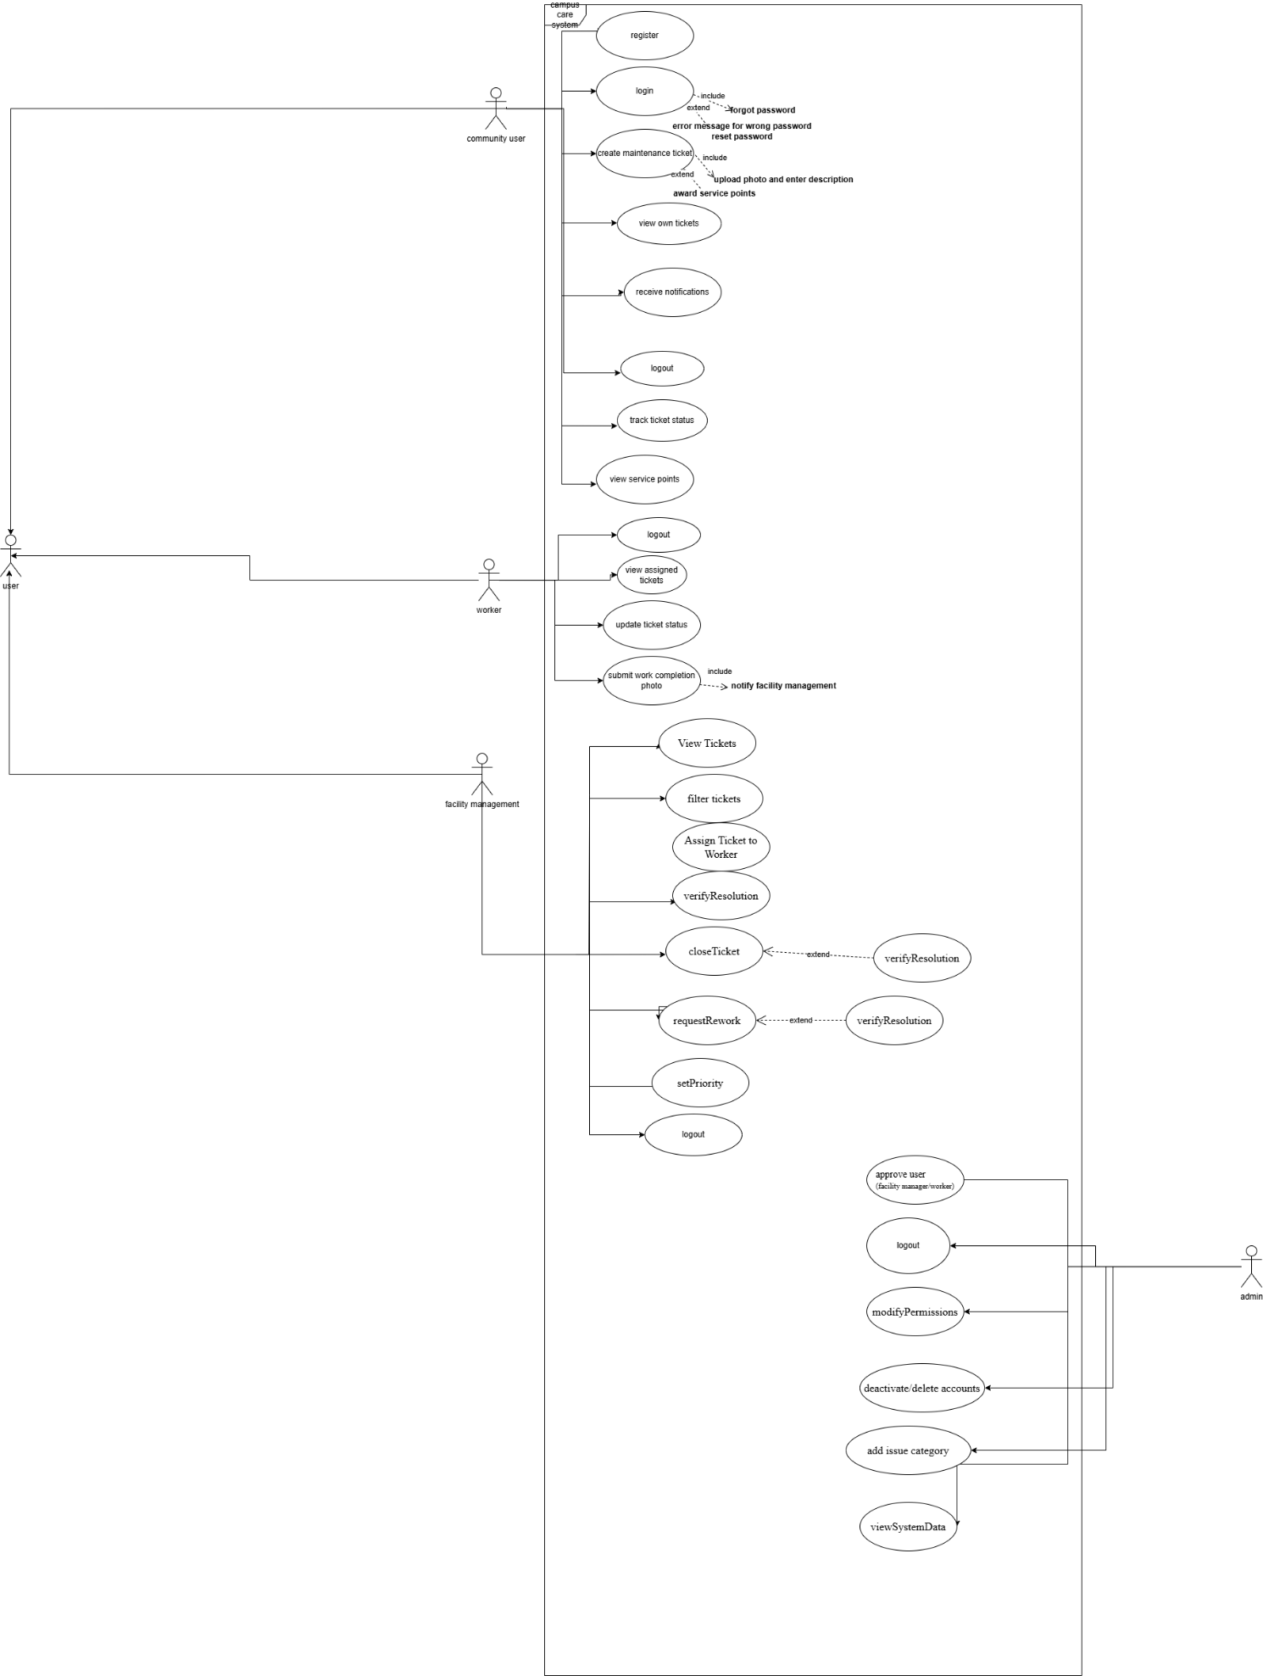

3. Non-functional Requirements:

- This section defines the quality attributes and constraints that the CampusCare system must satisfy. These requirements specify how the system performs its functions rather than what functions it performs.

3.1 Performance Requirements
- NFR-01 (Response Time):
The system shall load application pages and submit requests within three (3) seconds under normal operating conditions.
- NFR-02 (Concurrent Users):
The system shall support at least 500 simultaneous users without performance degradation.

3.2 Security Requirements
- NFR-03 (Authentication Security):
The system shall authenticate users securely using email and password credentials with JWT-based authentication to ensure that only authorized GIU community members can access the application.
- NFR-04 (API Security):
The system shall implement API rate limiting and input validation to protect against abuse, injection attacks, and malformed requests.
- NFR-05 (Access Control):
The system shall enforce role-based access control (RBAC) to restrict features and data access based on user roles.

3.3 Usability Requirements
- NFR-06 (Ease of Use):
The system shall provide an intuitive user interface that allows a community member to submit a maintenance ticket in under one (1) minute.
- NFR-07 (Clarity of Information):
The system shall clearly display ticket statuses and announcements in a manner understandable to non-technical users.

3.4 Reliability & Availability Requirements
- NFR-08 (Image Upload Reliability):
The system shall handle image uploads reliably, including retry mechanisms, even under unstable network conditions.
- NFR-09 (System Availability):
The system shall be available during university operating hours with minimal downtime for maintenance.

3.5 Data Management & Recovery Requirements
- NFR-10 (Backup & Recovery):
The system shall perform automated daily backups and provide a disaster recovery mechanism to restore system data in case of failure.

4. Constraints
C-01: Technology Constraint
The system must be developed using React Native (Expo) for the mobile application and Node.js with RESTful APIs for the backend, as specified by the project requirements.

C-02: University Domain Constraint
User registration must be restricted to official GIU university email addresses in order to prevent external users from accessing the system.

C-03: Role-Based System Constraint
The system must follow a Role-Based Access Control (RBAC) model, limiting system operations according to predefined roles (Community User, Worker, Facility Management, Admin).

C-04: Location Identification Constraint
Each ticket must specify a valid campus location (building, floor, and room) to ensure the issue can be accurately identified and assigned.

C-05: Institutional Scope Constraint
The system is designed only for internal GIU campus facility management and does not support external maintenance services, contractors, or financial transactions.

C-06: Mobile Device Constraint
The system is designed primarily for mobile device usage, which may limit screen space and interaction design compared to desktop systems.

5. Entity Relation Diagram
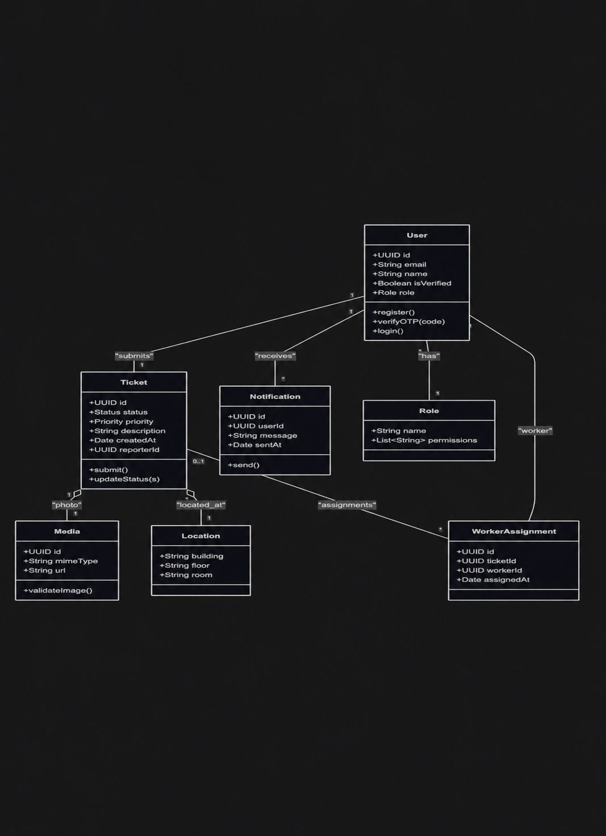

6. Technology Stack
The CampusCare system will use modern web and mobile development technologies to ensure scalability, reliability, and performance.
Frontend (Mobile Application)
- React Native (Expo)
- JavaScript
- Responsive mobile UI components
Backend
- Node.js
- Express.js
- RESTful API architecture
Database
- PostgreSQL or MySQL relational database
Cloud Services
- Cloud storage for image uploads
- Secure hosting environment
Security
- JWT-based authentication
- Password hashing and encryption
- Role-Based Access Control (RBAC)
System Performance Requirements
- Response Time: Page load times under three seconds
- Concurrent Users: Support for at least 500 simultaneous users
- API Security: Rate limiting and input validation
- Backup & Recovery: Automated daily backups with a disaster recovery plan

7. Future Scope of the Project
FS-01: Mobile Push Notifications
Implement real-time push notifications to inform users immediately when ticket statuses change.
FS-02: AI-Based Issue Classification
Integrate machine learning to automatically classify reported issues based on images and descriptions.
FS-03: Predictive Maintenance
Analyze historical ticket data to detect recurring facility problems and allow proactive maintenance.
FS-05: Multi-Campus Expansion
Extend the system to support multiple campuses or university branches.
FS-06: Integration with University Portal
Integrate CampusCare with the university's existing portal to allow single sign-on (SSO) authentication.
FS-07: Sustainability Tracking
Allow the system to track sustainability-related issues such as energy waste, water leaks, or recycling violations.

Extra UML Sequence Diagram :Ticket Lifecycle
